This document provides a draft “Treasure Hunt” of a church, pointing out its key features and getting children to discuss what different parts of the building and its furnishes are used for. Please feel free to download and adapt this resource for your school or uniformed group, replacing the pictures/information to reflect your own church!
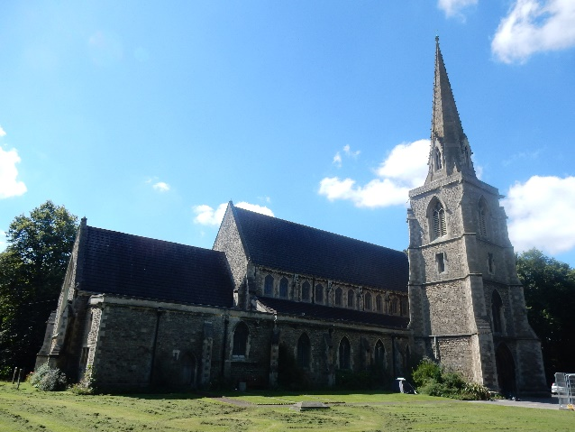
St Mark, Swindon was consecrated in 1845 and was built to serve the workers at the GWR’s Railway Works. It was designed by the famous architect George Gilbert Scott, who was responsible for many churches, including Christ Church in Old Town and St Mary’s Cathedral in Edinburgh, as well as parts of St Pancras station and the Albert Memorial in London.
Question: What does “consecrated” mean?
Answer: Make or declare a church sacred; the service that dedicates/opens it formally for its religious purpose.
The church was built with donations from the public, at a total of £6,000 (equivalent to £941,000 in 2026). The spire rises to 140 feet (43 metres) and can be clearly seen from Swindon station.
 | What is this? | What is it used for?
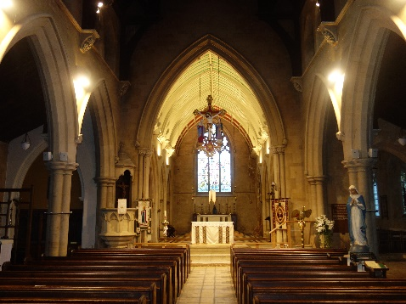 | Nave | This is where the congregation sit during services, in the wooden pews. The rows in between the pews (where you can walk) are called the aisles.  Can you spot the organ pipes? The choir used to sit in the gallery at the back of the church; can you find where they sit now?  What can you smell? The distinctive smell is incense – this is frequently used in services at St Mark
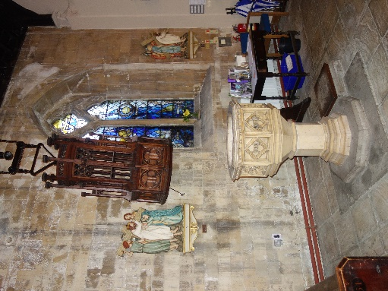 | Font | The font is used to baptise people. Like here, it is normally placed near the entrance to the church to welcome them in!
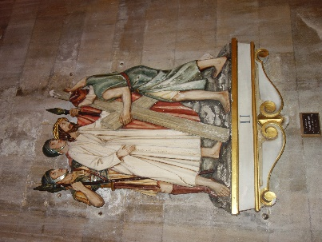 | Stations of the Cross | These are a series of fourteen pictures or carvings representing successive incidents during Jesus's progress from his condemnation by Pilate to his crucifixion and burial.  Can you find all 14? Do you know what each picture depicts?
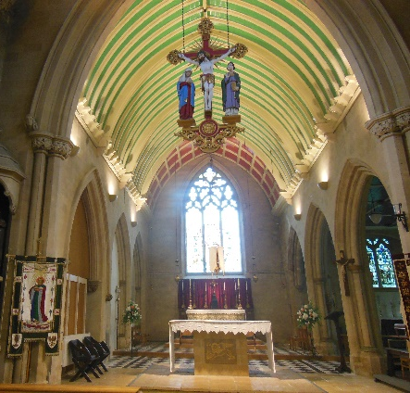 | Chancel and Altar | The altar is at the East end of the church.  This is where the main religious event happens; the bread and wine are blessed and given in communion services (this is known as “consecrating” it). The altar is in the “sanctuary”. This means “sacred place”  The chancel is the part of the church used by the vicar, clergy, and (in some cases) the choir; not the whole congregation!
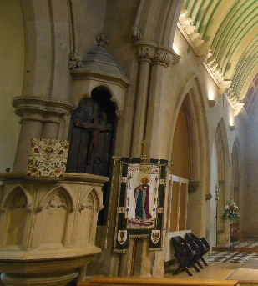 | Lectern and Pulpit | The pulpit is used by the priest to deliver the sermon (“Sunday lesson”) and Bible readings. Why do you think he is high up in the pulpit?
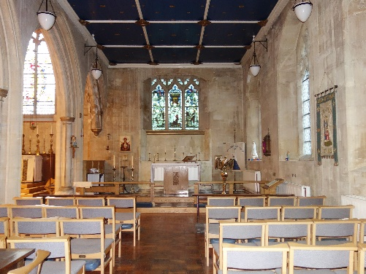 | Lady Chapel | This is a chapel dedicated to the Virgin Mary in a church or cathedral. It is typically located to the east of the high altar in a cathedral, or to the south of it in a church (such as here).
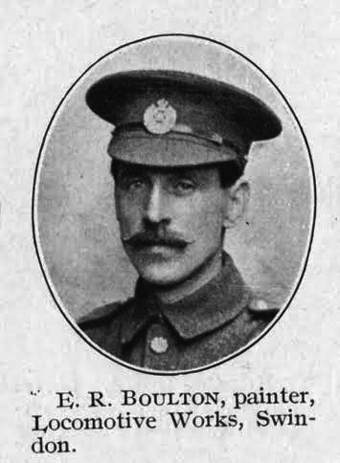 | Sapper Ernest Rice Boulton | In the Lady Chapel, there is a list of names, remembering the parishioners here who gave their lives in the First World War  See if you can find E. Boulton on this memorial. He was listed as a ringer at St Mark from 1904-1911, and was killed at the Battle of the Somme in 1916.
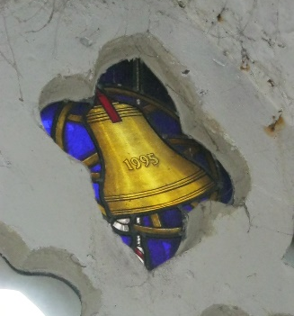 | Stained Glass Windows | Stained glass depicts many Saints, as well as Christian figures and events. Do you recognise any?  This particular piece can be found in the tower, and was designed to mark the church’s 150th birthday in 1995.
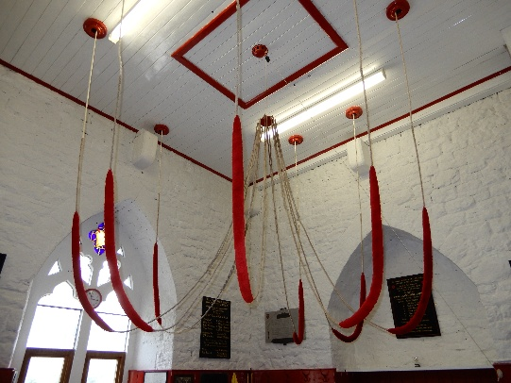  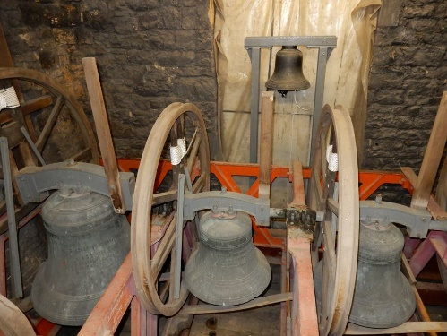 | Bell Tower | The bells are the biggest, loudest and oldest instruments in the church!  There are eight bells in the tower. The six older bells were cast (made) in 1904, by the Llewellins and James foundry in Bristol. Two new bells were added in 1927, and were cast at the Whitechapel foundry in London.  The biggest bell (called the Tenor) weighs around 550kg. That’s about the same as a large motorbike!  And maybe you will get a chance to have a go at ringing the bells this evening!

